Cleeves Primary School
Standards & Quality Report
Session 2024 – 2025

This summary report is provided for parents/carers and partners to outline our achievements and improvements during session 2024 - 2025 and to share our improvement priorities for 2025 - 2026. Throughout last session we took forward our improvement priorities as detailed in our school improvement plan. Using our approaches to self-evaluation, we have detailed in this report the impact of our work and identified how we plan to continue to improve outcomes for our children and young people.

The context of the school
Cleeves Primary School is a non-denominational, co-educational school which is part of Hillpark learning community. Our school, situated in the Priesthill area of Glasgow, is a new build and was officially opened on the 7th December 2009. It was an amalgamation of Burnbrae Primary, Househillmuir Primary and Nitshill Primary. It is a two-storey building with fourteen class bases, a gym hall, library and a dining hall. Two of our class bases house our nurture groups, ‘The Busy Bee Base’ and “The Coorie In”. Approximately 45% of pupils are entitled to Free School Meals. The school is surrounded by a mixture of rented accommodation and owner-occupied housing. The school benefits from some additional resources and funding which has recently been boosted by the Scottish Government’s allocation of Pupil Equity Funding to support ‘closing the gap’. The current school roll is 197. 81% of children and young people reside in SIMD Deciles 1&2. 49.5% of families are eligible for FSM. Attendance is presently 87.3%. Exclusions have been at 0% for the last few years. 65% of our learners are supported through the Staged Intervention Model.

Our achievements and improvements 2024 – 2025
We would like to highlight the following improvements/achievements agreed in consultation with school staff, parents and children.
Our priorities for 2024/25 were:
Achievement and Progress
- Improve the quality of feedback, assessment and levels of attainment in Literacy
- Improve the quality of feedback, assessment and levels of attainment in Numeracy & Maths.
Engagement, Participation and Inclusion:
- Embedding inclusive practice within our classrooms and the wider school community with a focus on equalities and continued focus on attendance
- We continued our enhanced nurture support for P4-7 and bespoke curriculum for young learners who required it. Children and young people within the Nurture/ Inclusion Provision are able to recognise and share their achievements, as well as plan their next targets.
What we did
- We provided targeted Literacy support to raise attainment across P1-4 with the continued implementation of Read, Write, Inc. This has helped our children reach the expected standard of phonics, develop their reading fluency and read with comprehension. It focuses on supporting the children to spell and write with confidence whilst developing co-operative behaviour and opportunities to articulate their ideas and understanding.
- In P4, learners have developed their writing skills through the class teacher engaging in professional learning through an Education Scotland course (CYPIC) which was then implemented into the P4 class with a focus on raising attainment.
- We focussed on raising attainment through quality Physical Education at P1, P2 and P4 developing teachers' confidence in delivering high-quality PE, providing examples of resources, content and pedagogy to improve teaching & learning in PE whilst making links between learning in PE to learning across the curriculum.
- Staff, children and parents worked together to embed the UNCRC into all aspects of school life to gain the Silver Rights Respecting School Award. This included staff training, curriculum development, policy updates, pupil participation through committees, assemblies, campaigns as well as parent feedback and contribution which ensured rights and equalities are part of the school culture where everyone understands and can talk about children’s rights.
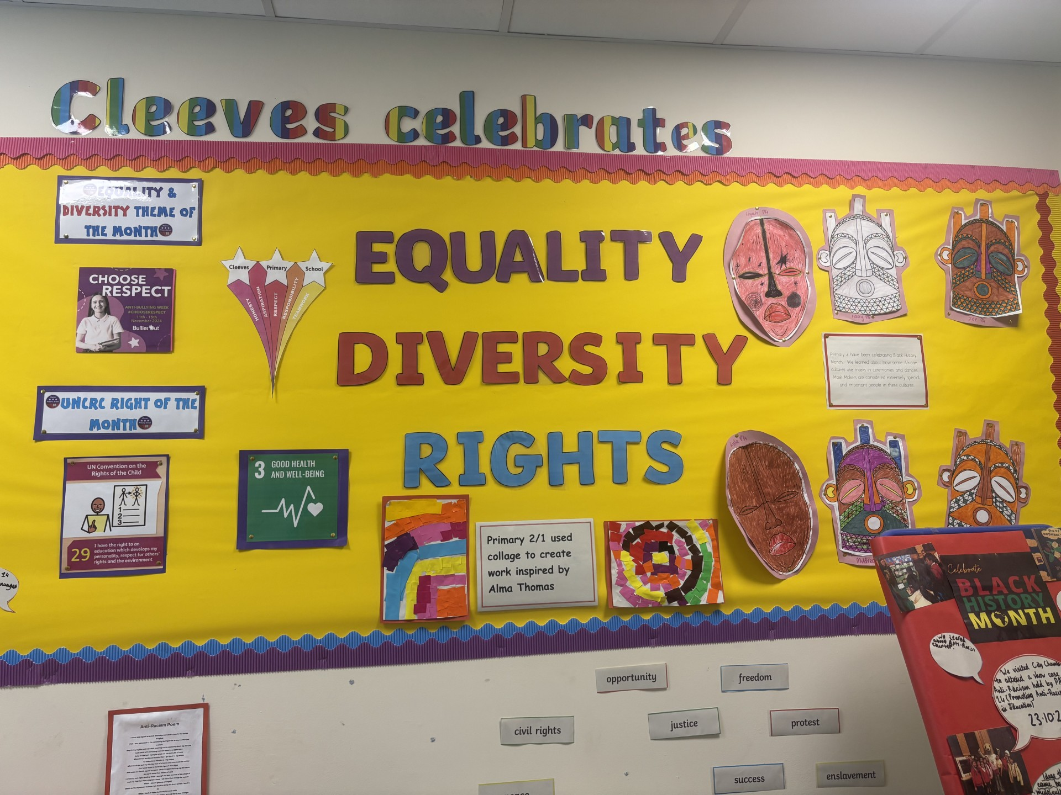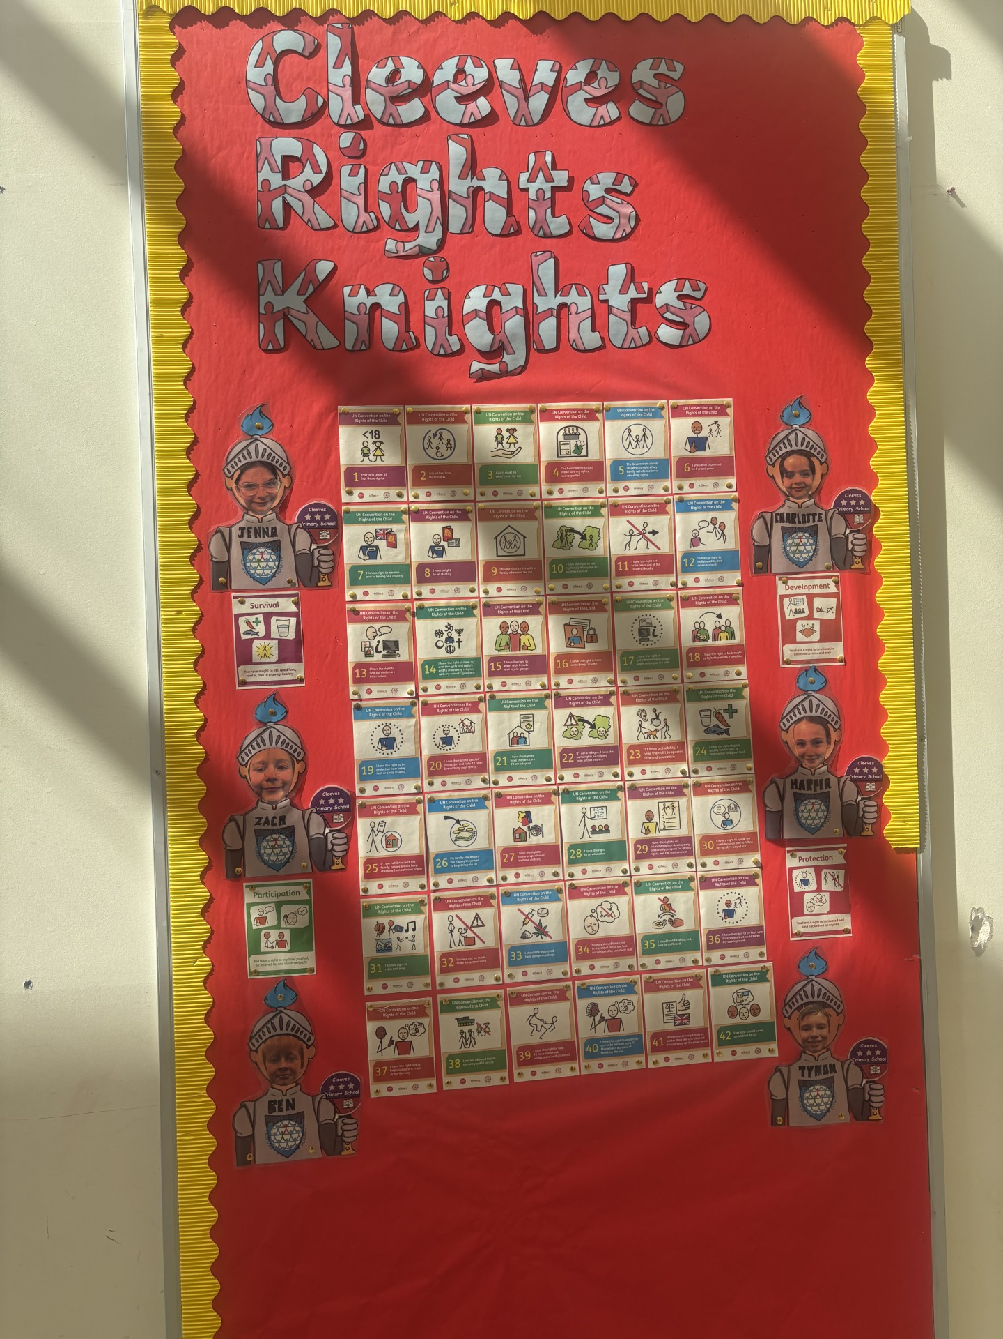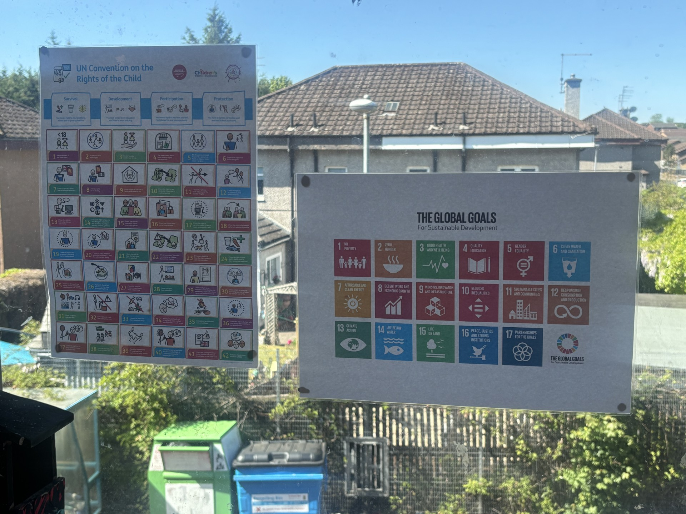
- Staff have been working together on assessment and tracking activities to make sure work is consistent across the school, helping all children achieve their best
- We made community links with Tesco through the Stronger Starts Fruit and Vegetable Grant which enabled children to access a wide variety of fruit daily, prepare soup/pasta/stir fry packs regularly throughout the year for parents and run family cooking workshop sessions during term 4 designed to bring families together, engaging in life skills and working on healthy, affordable, sustainable meals. Children followed recipes along with their adult learning different cooking techniques and cuisines from around the world.
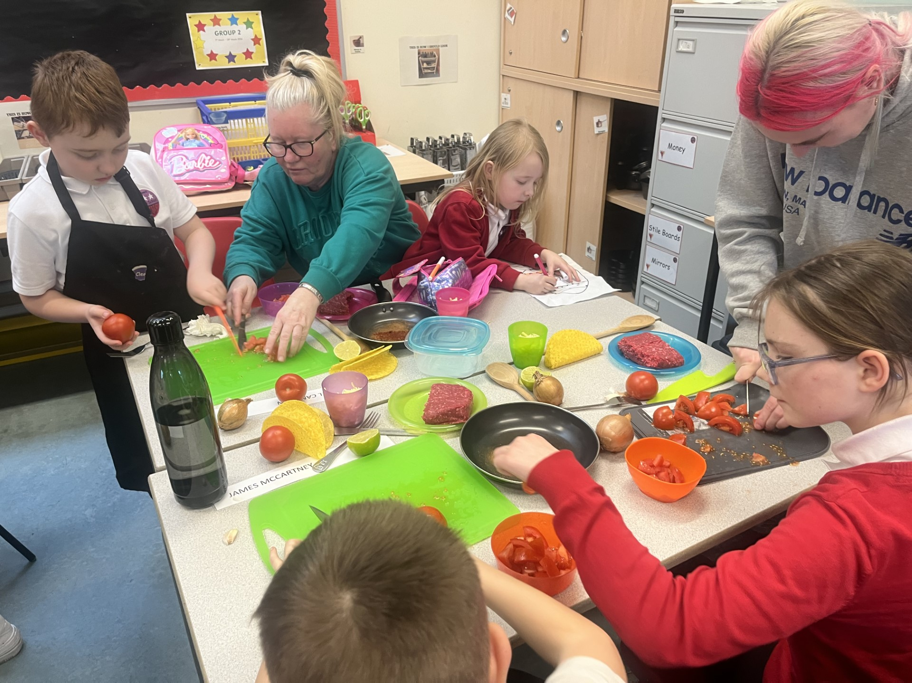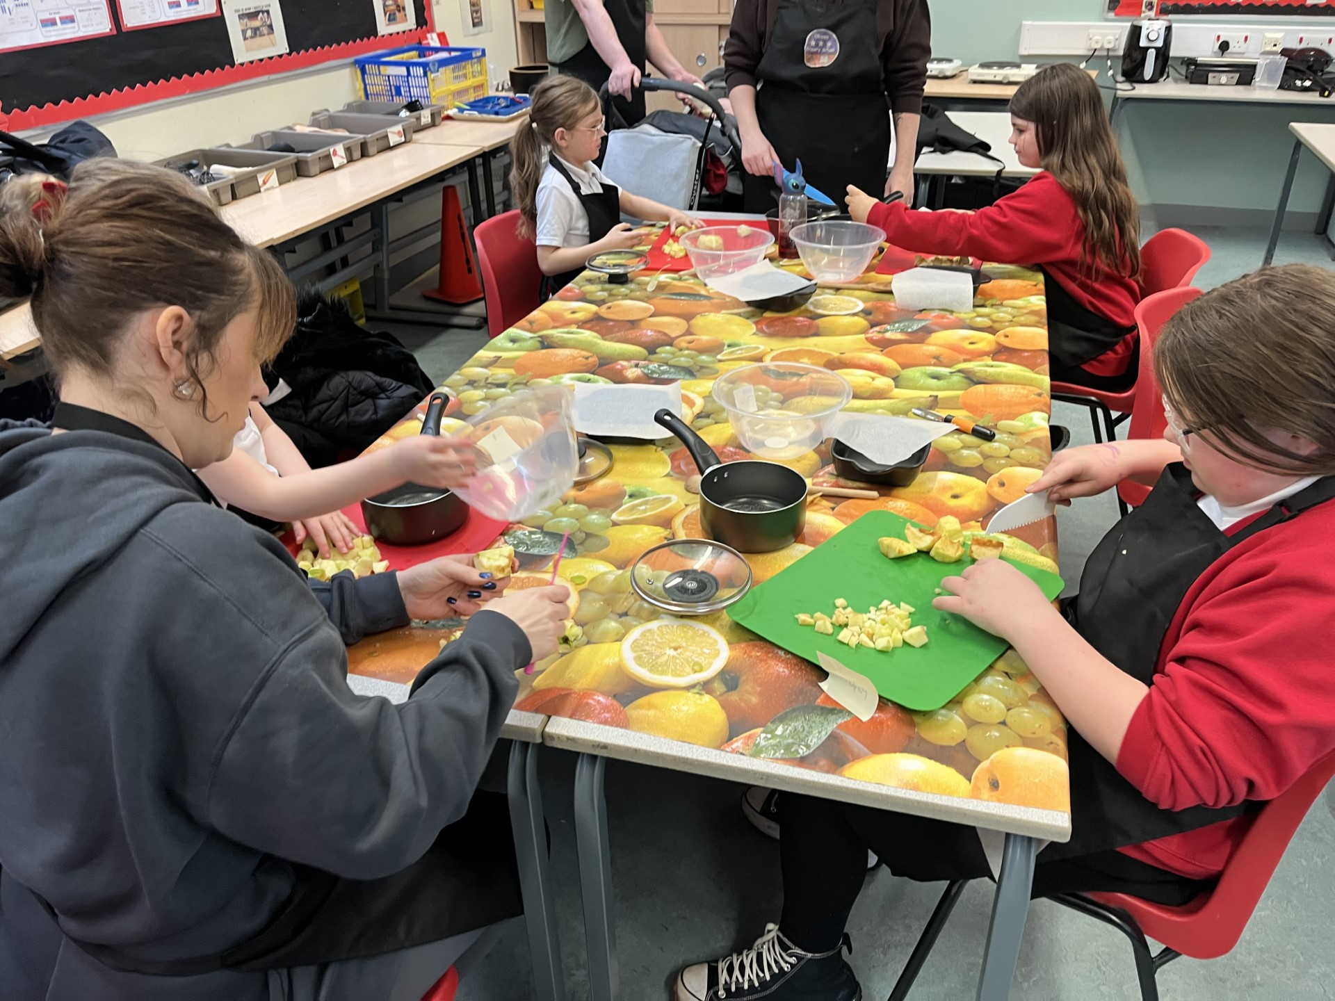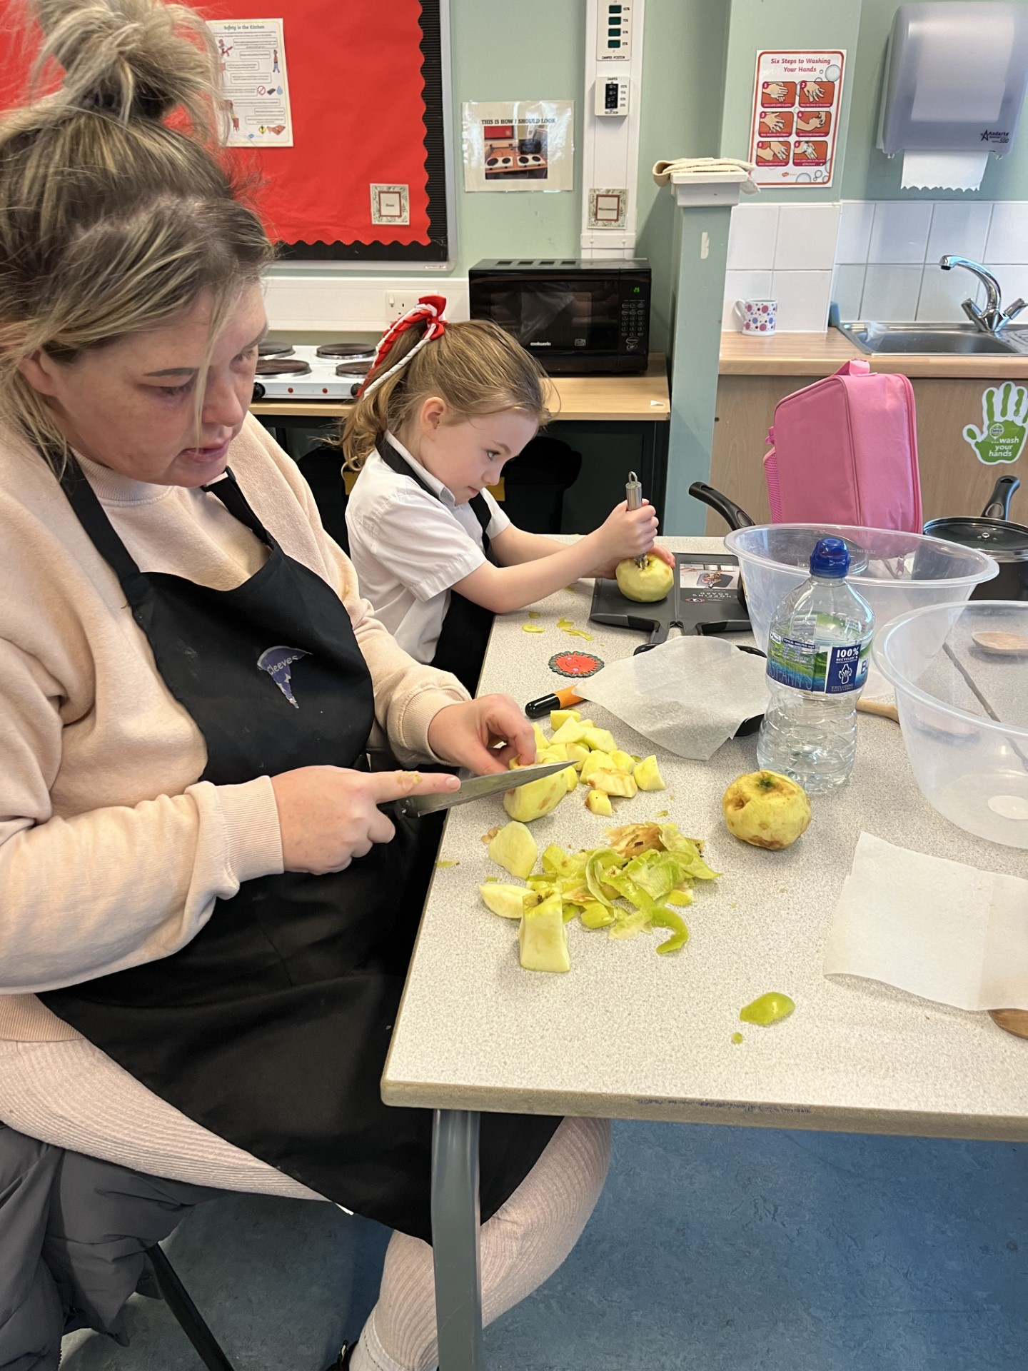
- We issued newsletters, used our school app and text messaging to communicate with families. We continued to use Seesaw and Showbie and “X” to support our learning and promote parental engagement. Workshops such as ‘ ‘Bookbug’, ‘Read, Write, Count’ Post 5 play with Glasgow Life, Cooking with Totnosh, Gardening and ‘Play Along Maths’ ran throughout the year.
- Highly effective Nursery to Primary and Primary to Secondary transitions took place from January 2024. Children had the opportunity to attend school in groups to meet their peers and class teacher. Enhanced transition meetings were held with parents to support new P1 /new 1st year children.
- We have expanded pupil leadership opportunities through our House Captains and Vice-Captain, Paths Pals, JRSO, Eco Committee, Rights Knights, Equality Ambassadors, Junior Librarians and Buddies as well as chi8ldren attending the PARTIE anti racism in the City Chambers which has led to increased confidence, responsibility, motivation and engagement, as well as fostering a culture where children feel heard, included and respected.
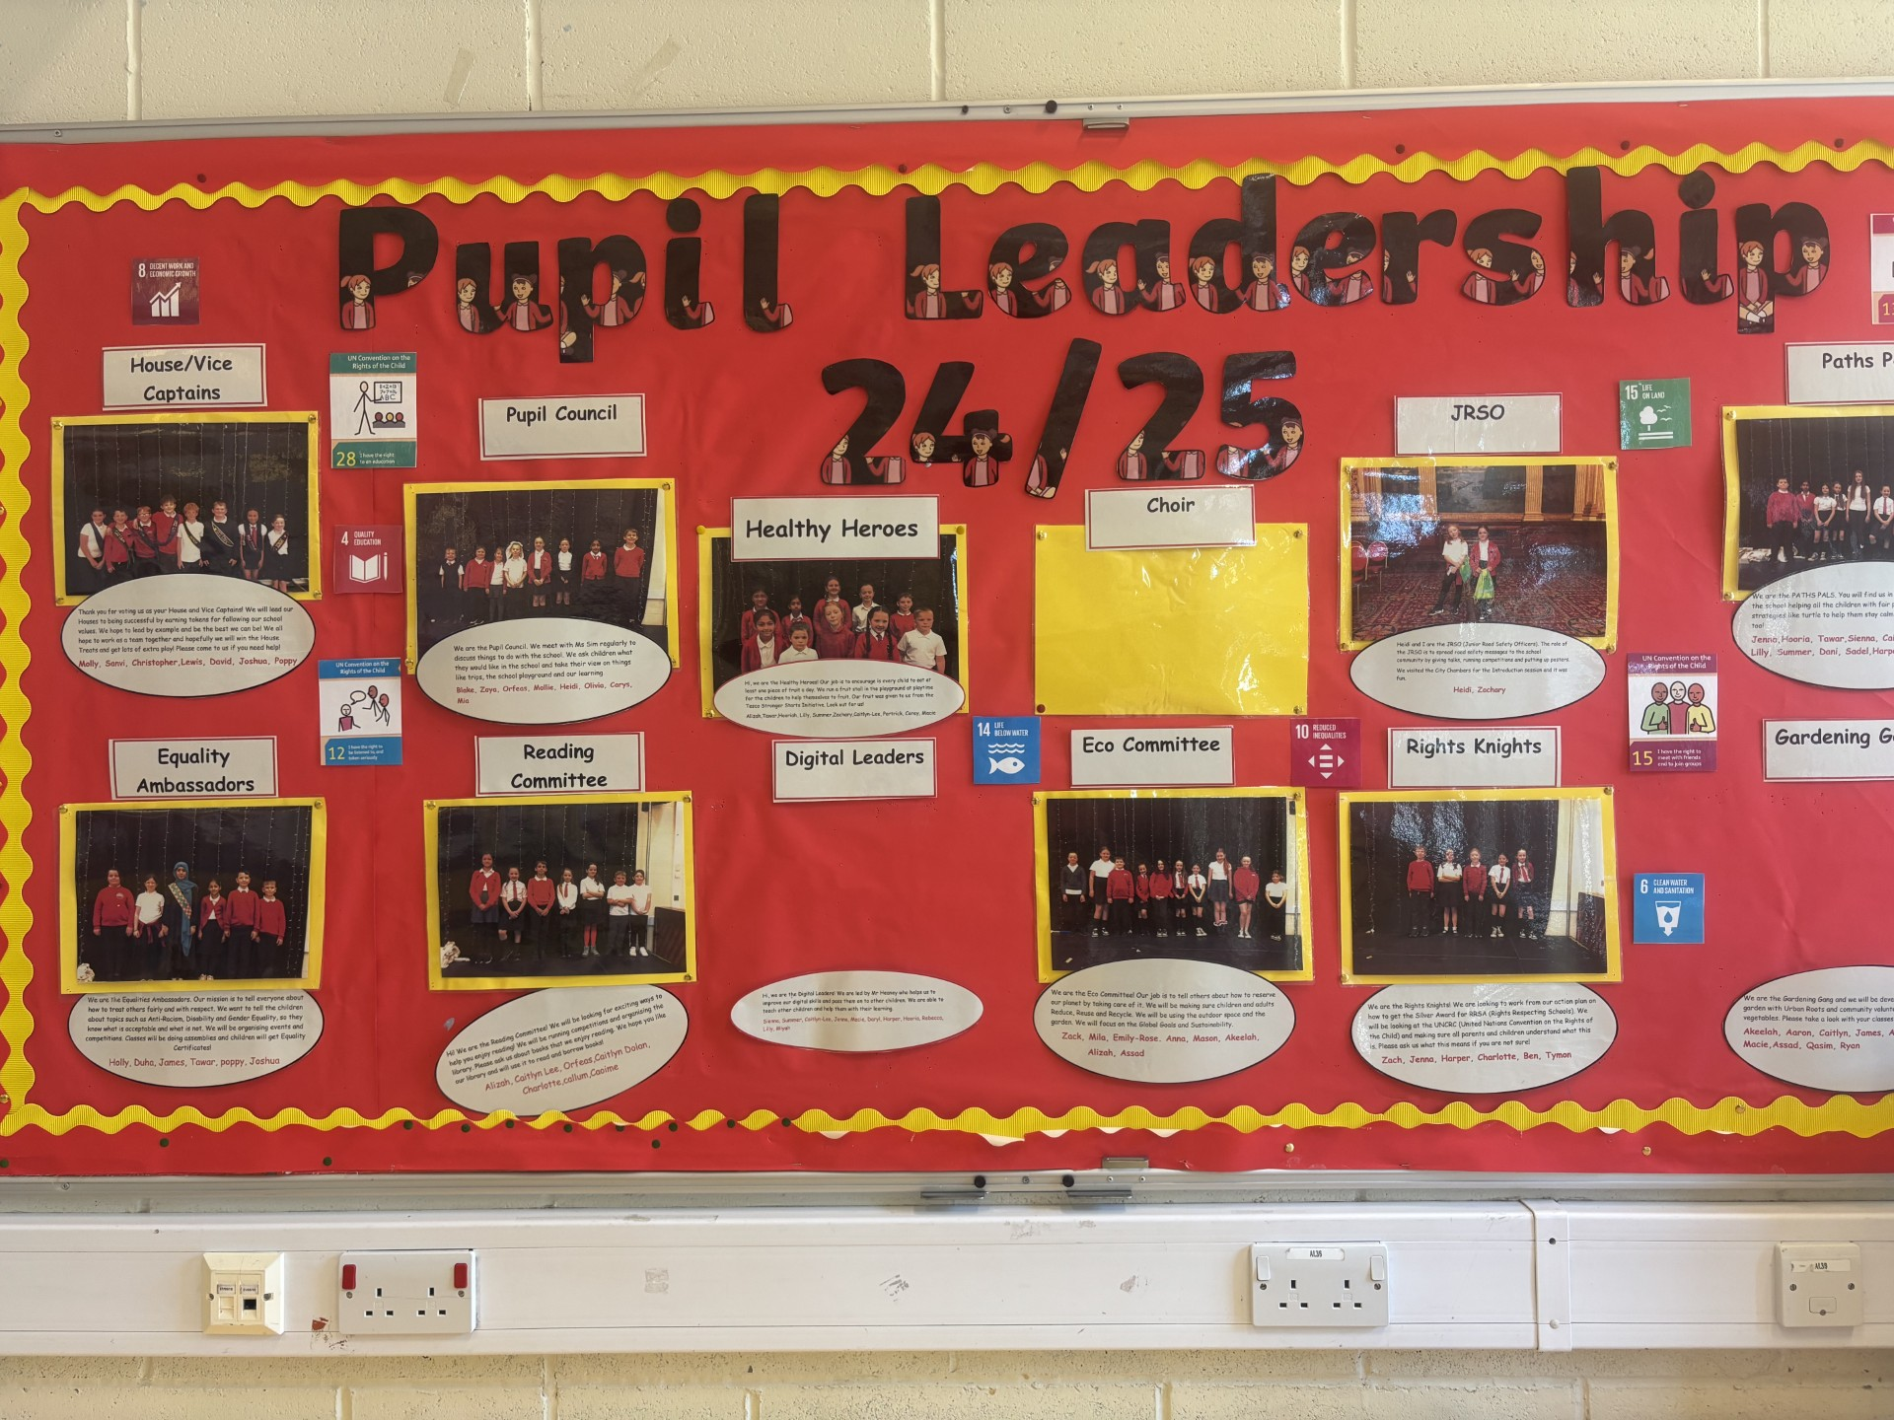
- Staff have engaged a wide range of professional learning activities to support inclusive practice.
- Continuing our expressive arts journey and development of pupil talking and listening skills, staff worked with Scottish Opera which finished with a performance at the Clyde Auditorium in front of over 3000 people. Primary 7s attended a violin experience day at the City Chambers and have now continued with their lessons at High School.
We were inspected by Education Scotland in October 2025 and they highlighted :-
“The highly-effective leadership of the headteacher. Supported ably by the senior leadership team”
“The outstanding approaches to nurture and inclusion”
“The friendly, confident children who display the school values very well, supporting each other to learn and achieve”
“The rich opportunities provided by staff and partners to enable children to engage in new experiences and develop a range of skills for learning, life and work”
Pupil Equity Funding
In session 2024-25, the school used the PEF allocation to directly raise attainment, improve attendance and engagement and support children’s wellbeing. The table below outlines our key interventions:

PEF Intervention
Two additional teachers: Raising Attainment in Literacy, Numeracy and Health and Wellbeing
Calming Minds Therapist: supporting children’s wellbeing and engagement
Music Therapist: supporting children’s wellbeing and engagement across the school
One Support for Learning Worker to support increasing attainment
8 interactive smart boards installed in classrooms
Extra-Curricular Programme – Theatre visits to Pantomime and school outings to Dumfries House and Calderglen
Transport for P7 Residential Experience to Dalguise – Health and Wellbeing

Attendance and Exclusion data
Attainment
The table below summarises attainment as of June 2025.
We have collected data in a variety of ways and tracked pupil’s progress across the curriculum. The table below summarises achievement of a level and this information allows us to identify strategies to close the attainment gap.
Our Attendance was 87.3% and we had 0 formal exclusions during session 2024 – 2025.

 | Reading | Writing | L&T | Numeracy and Maths
Primary 1: Early | 59.4% | 59.4% | 68.8% | 65.6%
Primary 4: First | 63.0% | 55.6% | 63.0% | 63.0%
Primary 7: Second | 60.9% | 60.9% | 69.6% | 65.2%

Our improvement plan priorities 2025 – 2026
Here is what we plan to improve in session 2025-26

1. Achievement and Progress:
Improve the quality of active and collaborative learning, feedback and levels of attainment in Literacy and Numeracy. Improve the quality of the teaching and learning of writing through engaging with the “Write on Track” programme.

2. Engagement, Participation and Inclusion & Wellbeing and Learning:
Embedding inclusive practice within our classrooms and the wider school community with a focus on trauma informed practice and a continued focus on attendance and equalities particularly on working towards gaining our Gold Rights respecting School award.
We are continuing to develop whole community food and nutrition education through Stronger Starts Fruit and Vegetable Grant, whole school curriculum-based cooking lessons and opportunities for family learning through cooking club.

 | How Good Is Our School 4 Quality Indicator (QI) | Evaluation
 | Leadership of Change (QI 1.3) | Very Good
 | Learning Teaching and Assessment (QI 2.3) | Good
 | Ensuring Wellbeing Equality and Inclusion (QI 3.1) | Excellent
 | Raising Attainment and Achievement (QI 3.2) | Good

How to find out more about our school
Contact us directly if you require further information about our school or if you wish to comment on this report.

Our contact e-mail address is: Headteacher@cleeves-pri.glasgow.sch.uk

Our telephone number is: 0141 880 5305

Our school address is: Cleeves Primary School, 271 Househillmuir School, Glasgow, G53 6NL

Further information is also available in our newsletters, on our school website, and in our school handbook and via our app “School App for Parents”

